**A circuit to improve power factor of a fluorescent lamp:**

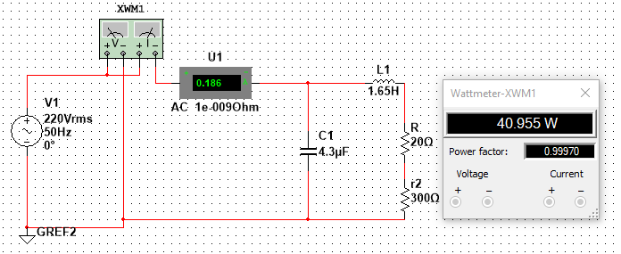

**Table:**

|  |  |  |  |  |
| --- | --- | --- | --- | --- |
| C | U(V) | I(A) | P (W) | Cos  Φ |
| 0 | 220 | 0.358 | 40.951 | 0.520 |
| 1 μF | 220 | 0.3 | 40.956 | 0.620 |
| 2.2 μF | 220 | 0.24 | 40.952 | 0.775 |
| 3.2 μF | 220 | 0.205 | 40.953 | 0.916 |
| 4.3 μF | 220 | 0.186 | 40.955 | 0.999 |
| 4.6 μF | 220 | 0.187 | 40.956 | 0.996 |
| 5.7 μF | 220 | 0.21 | 41.036 | 0.893 |
| 6.9 μF | 220 | 0.257 | 40.948 | 0.723 |
| 7.9 μF | 220 | 0.31 | 40.961 | 0.600 |
| 9.87μF | 220 | 0.428 | 40.958 | 0.434 |

**The curve $I=f(c)$:**

**Analysis:**

From the chart above it is quite evident that the current flow of the circuit reduces as the capacitance increases. After a certain point the current rises again.

It is because at the beginning, the power factor was lagging as there was no capacitor; only the inductor and resistors were connected. The circuit started to take less current as we increase the capacitance which decreased the power factor to nearly unity. After a certain point the current flow started to rise again as the capacitor connected to the circuit was more than enough to made the power factor unity which made the power factor leading; thus, increased the current flow of the circuit again.

**The effectiveness of my method:**

The goal is to make the power factor of the circuit unity or close to unity. When we used an inductor of the fluorescent lamp, it made the power factor lagging (0.520). From the reading of the oscilloscope it is seen that the angle between voltage and current is 58.66°.

To improve the power factor of the circuit, a capacitor is used in parallel to the inductor and filament lamp (which in this case a resistor). The best value of the capacitor (4.3 μF) to make the circuit nearly unity is taken from the chart above. From the wattmeter reading, it is clear that the power factor is nearly 1. From the reading of the oscilloscope it also clarifies that the angle between the voltage and current is indeed nearly zero (2.56°). So attaching a 4.3μF capacitor improved the power factor of the fluorescent lamp to nearly 1.

**Appendix:**

**Simulation Pictures:**

